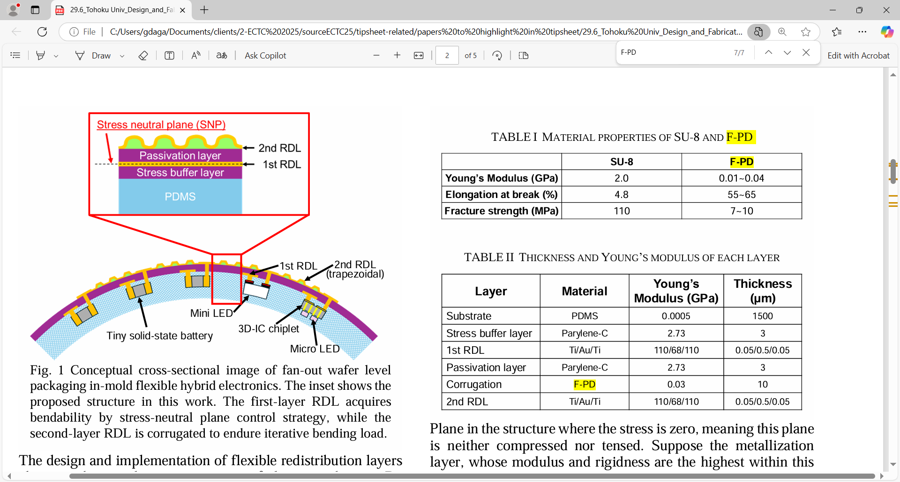 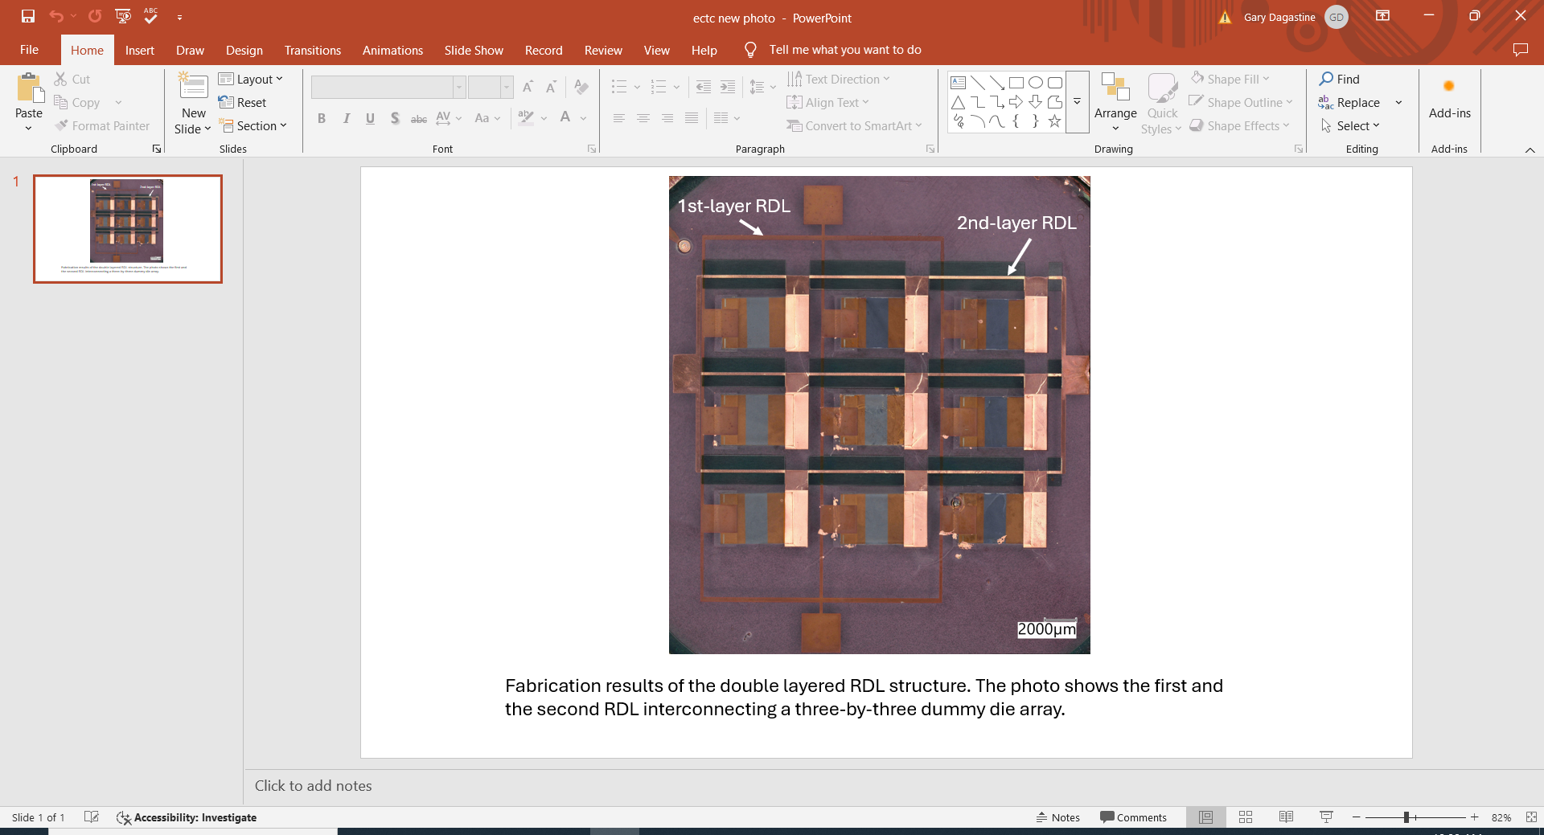

**Progress in Flexible Hybrid Electronics**: Flexible hybrid electronics (FHE) is an emerging technology that integrates rigid semiconductor components like sensors, microcontrollers and communication modules onto a flexible substrate. It is a significant advancement over traditional flexible electronics because it enables systems that are not only lightweight and flexible, but also capable of delivering high performance. However, ensuring the mechanical reliability of flexible systems under constant movement with repeated bending, twisting and deformation is critical in applications such as soft robotics, flexible displays and wearable systems. Key to that ability are flexible/bendable redistribution layers (RDLs), which facilitate the distribution of electrical signals and power across the device while maintaining flexibility. They also contribute to the miniaturization of electronic devices because RDL flexibility allows for innovative designs that can conform to the contours of the human body or other surfaces. However, single-layer RDL designs lack the capability to connect multi-terminal functional components, while two-dimensional serpentine RDLs require horizontal space to accommodate bending-induced deformation.

At ECTC, Tohoku Univ. researchers will describe a novel methodology for interconnecting FHE functional components using a double-layer RDL, based on fan-out wafer-level packaging (FOWLP) techniques. They conducted a feasibility study of their approach, in which after 100 25mm-radius bending cycles, the resistance of the first- and second-layer RDL increased by only 9.9% and 16.1%, respectively, indicating relatively high mechanical reliability. The reliability can be further enhanced by a controlled passivation layer on the top of the second RDL.

**The images above show:**

* **Left** – A conceptual cross-sectional image of FOWLP for flexible hybrid electronics. The inset shows the proposed Tohoku Univ. structure. The first-layer RDL acquires bendability using a stress-neutral plane control strategy (i.e., positioning bending points at places in the RDL where the plane will be neither compressed nor tensed), while the second-layer RDL is corrugated to endure iterative bending loads.
* **Right** – A photo showing fabrication results of the double-layered RDL structure. It shows the first and second RDLs interconnecting a 3x3 dummy die array.

**(Paper 29.5, “*Design and Fabrication of Bendable Double-layer RDL Metallization Based on FOWLP for In-Mold Flexible Hybrid Electronics (iFHE),”* C. Liu et al, Tohoku Univ.)**